Structuring Machine Learning Projects -

Orthogonalization – find a set of orthogonal vectors (linearly interdependent) such that they span the same sub-space.


Must always have a single number evaluation metric. - Tends to speed up the iterative process of building a ML model.
F1 Score – Harmonic Mean of Precision and Recall.



What if we are not able to get single number evaluation metric?

Satisficing and Optimizing metric


Train/dev/test distributions

dev and test set must come from same distribution
randomly shuffle data into dev/test set



Size of dev and test sets

Old way of splitting data

70%Train 30%Test
60%Train 30%Dev 10%Test

But now we have much larger datasets. (Millions of examples)

98%Train 1%Dev 1%Test

Size of Test Set -

Set your test set to be big enough to give high confidence in the overall performance of your system.

When to change dev/test sets metrics






Bayes Optimal Error – Best Possible Error.

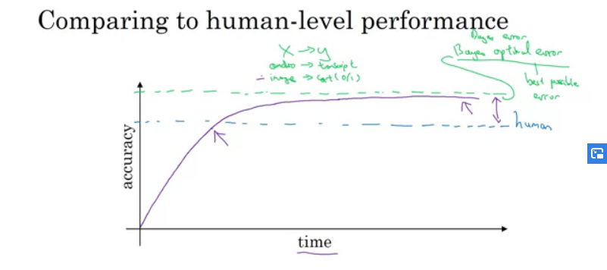
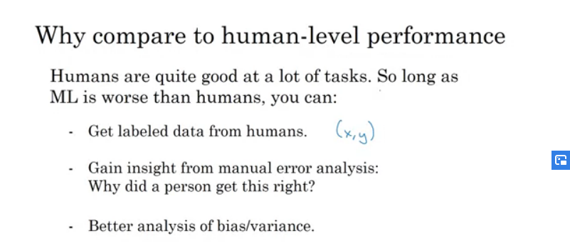
Avoidable Bias



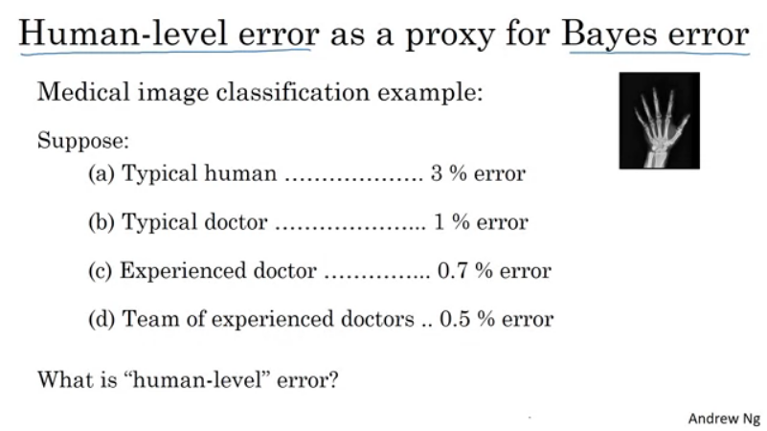
(d) -> answer

In first example it doesn’t matter what we choose as human level error
Simmilary in second example.
You focus more on the variance error.

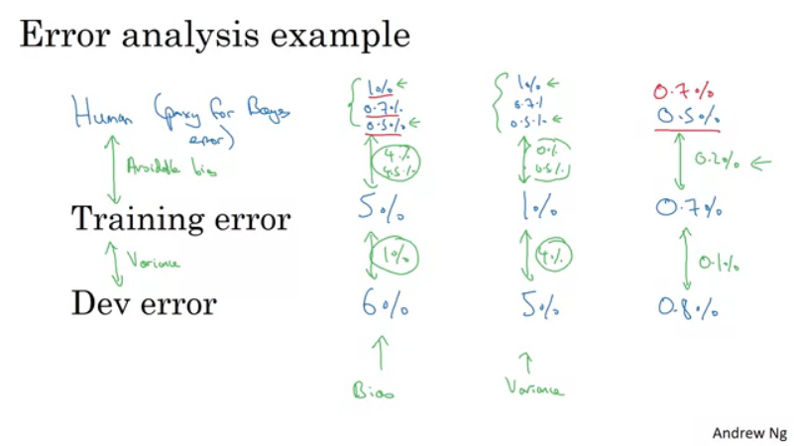

Improving your model performance -

